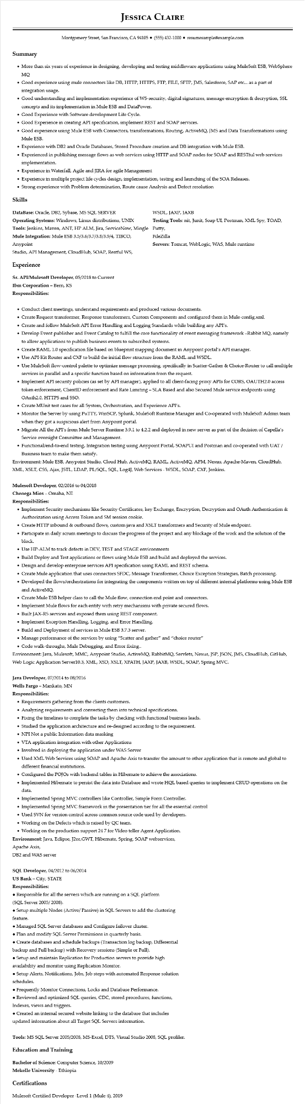
JESSICA CLAIRE
Montgomery Street, San Francisco, CA 94105 ⚫ (555) 432-1000⚫ resumesample@example.com
Summary
• More than six years of experience in designing, developing and testing middleware applications using MuleSoft ESB, WebSphere MQ
• Good experience using mule connectors like DB, HTTP, HTTPS, FTP, FILE, SFTP, JMS, Salesforce, SAP etc... as a part of integration usage.
• Good understanding and implementation experience of WS-security, digital signatures, message encryption & decryption, SSL concepts and its implementation in Mule ESB and DataPower.
• Good Experience with Software development Life Cycle.
• Good Experience in creating API specification, implement REST and SOAP services.
• Good experience using Mule ESB with Connectors, transformations, Routing, ActiveMQ, JMS and Data Transformations using Mule ESB.
• Experience with DB2 and Oracle Databases, Stored Procedure creation and DB integration with Mule ESB.
Experienced in publishing message flows as web services using HTTP and SOAP nodes for SOAP and RESTful web services implementation.
• Experience in Waterfall, Agile and JIRA for agile Management
• Experience in multiple project life cycles design, implementation, testing and launching of the SOA Releases.
• Strong experience with Problem determination, Route cause Analysis and Defect resolution
Skills
DataBase: Oracle, DB2, Sybase, MS SQL SERVER Operating Systems: Windows, Linux distributions, UNIX
Tools: Jenkins, Maven, ANT, HP ALM, Jira, ServiceNow, Mingle Mule Integration: Mule ESB 3.5/3.6/3.7/3.8/3.9/4, TIBCO, Anypoint
Studio, API Management, CloudHub, SOAP, Restful WS,
Experience
Sr. API/Mulesoft Developer, 05/2018 to Current
Ibm Corporation - Bern, KS
Responsibilities:
WSDL, JAXP, JAXB
Testing Tools: nit, Junit, Soap UI, Postman, XML Spy, TOAD, Putty, FileZilla
Servers: Tomcat, WebLogic, WAS, Mule runtime
• Conduct client meetings, understand requirements and produced various documents.
• Create Request transformer, Response transformers, Custom Components and configured them in Mule-config.xml.
• Create and follow MuleSoft API Error Handling and Logging Standards while building any API's.
• Develop Event publisher and Event Catalog to fulfill the core functionality of event messaging framework -Rabbit MQ, namely to allow applications to publish business events to subscribed systems.
• Create RAML 1.0 specification file based on blueprint mapping document in Anypoint portal's API manager.
• Use API-Kit Router and CXF to build the initial flow structure from the RAML and WSDL.
• Use MuleSoft flow-control palette to optimize message processing, specifically in Scatter-Gather & Choice-Router to call multiple services in parallel and a specific function based on information from the request.
• Implement API security policies (as set by API manager), applied to all client-facing proxy APIs for CORS, OAUTH2.0 access token enforcement, ClientID enforcement and Rate Limiting - SLA Based and also Secured Mule service endpoints using OAuth2.0, HTTPS and SSO.
• Create MUnit test cases for all System, Orchestration, and Experience API's.
• Monitor the Server by using PuTTY, WinSCP, Splunk, MuleSoft Runtime Manager and Co-operated with MuleSoft Admin team when they got a suspicious alert from Anypoint portal.
• Migrate All the API's from Mule Server Runtime 3.9.1 to 4.2.2 and deployed in new server as part of the decision of Capella's Service oversight Committee and Management.
• Functional/end-to-end testing, Integration testing using Anypoint Portal, SOAPUI and Postman and co-operated with UAT / Business team to make them satisfy.
Environment: Mule ESB, Anypoint Studio, Cloud Hub, ActiveMQ, RAML, ActiveMQ, APM, Nexus, Apache-Maven, CloudHub, XML, XSLT, CSS, Ajax, JSTL, LDAP, PL/SQL, SQL, Log4J, Web Services - WSDL, SOAP, CXF, Jenkins.
Mulesoft Developer, 02/2016 to 04/2018
Chenega Mios - Omaha, NE
Responsibilities:
• Implement Security mechanisms like Security Certificates, key Exchange, Encryption, Decryption and OAuth Authentication & Authorization using Access Token and SM session cookie.
• Create HTTP inbound & outbound flows, custom java and XSLT transformers and Security of Mule endpoint.
• Participate in daily scrum meetings to discuss the progress of the project and any blockage of the work and the solution of the
block.
• Use HP-ALM to track defects in DEV, TEST and STAGE environments
• Build Deploy and Test applications or flows using Mule ESB and build and deployed the services.
• Design and develop enterprise services API specification using RAML and REST schema.
• Create Mule application that uses connectors SFDC, Message Transformer, Choice Exception Strategies, Batch processing.
• Developed the flows/orchestrations for integrating the components written on top of different internal platforms using Mule ESB and ActiveMQ.
• Create Mule ESB helper class to call the Mule flow, connection end point and connectors.
• Implement Mule flows for each entity with retry mechanisms with private secured flows.
• Built JAX-RS services and exposed them using REST component.
• Implement Exception Handling, Logging, and Error Handling.
• Build and Deployment of services in Mule ESB 3.7.3 server.
• Manage performance of the services by using "Scatter and gather" and "choice router"
• Code walk-throughs, Mule Debugging, and Error fixing..
Environment: Java, Mulesoft, MMC, Anypoint Studio, ActiveMQ, RabbitMQ, Servlets, Nexus, JSP, JSON, JMS, CloudHub, GitHub,
Web Logic Application Server10.3, XML, XSD, XSLT, XPATH, JAXP, JAXB, WSDL, SOAP, Spring MVC.
Java Developer, 07/2014 to 08/2016
Wells Fargo - Mankato, MN
Responsibilities:
• Requirements gathering from the clients customers.
• Analyzing requirements and converting them into technical specifications.
• Fixing the timelines to complete the tasks by checking with functional business leads.
• Studied the application architecture and re-designed according to the requirement.
• NPI Not a public Information data masking
• VTA application integration with other Applications
• Involved in deploying the application under WAS Server
• Used XML Web Services using SOAP and Apache Axis to transfer the amount to other application that is remote and global to different financial institutions.
• Configured the POJOS with backend tables in Hibernate to achieve the associations.
• Implemented Hibernate to persist the data into Database and wrote HQL based queries to implement CRUD operations on the
data.
• Implemented Spring MVC controllers like Controller, Simple Form Controller.
• Implemented Spring MVC framework in the presentation tier for all the essential control
• Used SVN for version control across common source code used by developers.
• Working on the Defects which is raised by QC team.
• Working on the production support 24 7 for Video teller Agent Application.
Environment: Java, Eclipse, J2ee,GWT, Hibernate, Spring, SOAP webservices, Apache Axis,
DB2 and WAS server
SQL Developer, 04/2012 to 06/2014
US Bank - City, STATE
Responsibilities:
• Responsible for all the servers which are running on a SQL platform
(SQL Server 2005/2008).
• Setup multiple Nodes (Active/ Passive) in SQL Servers to add the clustering
feature.
• Managed SQL Server databases and Configure failover cluster.
• Plan and modify SQL Server Permissions in quarterly basis.
• Create databases and schedule backups (Transaction log backup, Differential
backup and Full backup) with Recovery sessions (Simple or Full).
• Setup and maintain Replication for Production servers to provide high
availability and monitor using Replication Monitor.
• Setup Alerts, Notifications, Jobs, Job steps with automated Response solution
schedules.
• Frequently Monitor Connections, Locks and Database Performance.
• Reviewed and optimized SQL queries, CDC, stored procedures, functions,
Indexes, views and triggers.
• Created an internal secured website linking to the database that includes
updated information about all Target SQL Servers information.
Tools: MS SQL Server 2005/2008, MS-Excel, DTS, Visual Studio 2008, SQL profiler.
Education and Training
Bachelor of Science: Computer Science, 10/2009
Mekelle University - Ethiopia
Certifications
Mulesoft Certified Developer -Level 1 (Mule 4), 2019

